LONG-TERM EFFECTS OF PARTICIPATION IN HIGH SCHOOL ATHLETICS

By Matthew R. Wiederholt

A dissertation submitted in partial fulfillment
of the requirements for the degree of
DOCTOR OF EDUCATION
at
EDGEWOOD COLLEGE
2009

Copyrighted by Matthew R. Wiederholt, 2009

ABSTRACT
The purpose of this study was to determine if there are long-term effects of participation in high school athletics specifically as it relates to academic achievement and leadership development. The participants in the study were individuals that graduated from a rural high school in Southwestern Wisconsin in 1993. These participants completed a survey on their perceptions on the long-term effects of participation in high school athletics. The findings did indicate that there are long-term benefits of participation in high school athletics as it pertains to academic achievement and leadership development.

ACKNOWLEDGEMENTS
I would not have been able to complete this dissertation without the help and support of numerous individuals. First, I need to thank my best friend and lovely wife, Katie, who sacrificed a great deal of her time in watching our beautiful two young children, Emily and Ava, so that I could dedicate so much time into completing this study and earning my doctorate. I also would like to thank Dr. Barbara Sloan and Laura Nelson for all of their support and encouragement along with Kristopher Kreul, who tolerated numerous formatting questions and played a huge part in helping me create this document.
At Edgewood, I thank my advisor, Dr. John Kammerud, for his time, energy, and support in helping me work through this process. Special gratitude goes out to Dr. Mary Ellen Gevelinger for her wisdom regarding research and her colleagues who helped me survive the process: Dr. Steve Koch, Dr. Jane Belmore, Dr. Peter Burke, Dr. Gene Thieleke. I also would like to thank the other members of my cohort for helping to make the weekends in class pass by so quickly as we often laughed and shared our sorrow on both a personal and professional level. As I look at the peers in my cohort, I rest assured that we have some great current and future leaders in education.

Table of Contents
CHAPTER 1 1
INTRODUCTION 1
Problem Statement 1
Significance of the Study 2
Methodology Sources 4
Theoretical Model 6
Research Questions 8
CHAPTER 2 9
REVIEW OF THE LITERATURE 9
Introduction 9
High School Athletics and Academic Achievement 13
High School Athletics and Leadership Development 15
CHAPTER 3 19
METHODOLOGY 19
Design 19
Orientation 19
Data Sources 20
Data Collection 22
Data Management and Analysis 22
Limitations to the Study 23
CHAPTER 4 24
FINDINGS 24
Review of the Plan 24
Review of Research Procedures 24
Review of the Research Questions 25
Evidence Regarding the Research Questions 25
National Honor Society Members and Non-Members 27
Seasons Participated in High School Athletics 33
Figure 4 represents the average response of former student athletes based on the number of seasons that they participated in high school athletics. These former student athletes were broken into categories based on 1-4, 5-8, 9-12, and 13-16 seasons that they participated in athletics while in high school. 33
Open-Ended Responses 39
Summary of Findings 43
CHAPTER 5 45
CONCLUSIONS AND RECOMMENDATIONS 45
Conclusions 45
Academic Achievement 46
Leadership Development 48
Implications 50
Recommendations 51
REFERENCES 55
APPENDIXES 59

FIGURES

Figure 1 Theoretical Model – Graphic Representation…………………...……………..7
Figure 2 Average Responses to 10 Survey Question………………......………………..26
Figure 3 Average Responses of Former Student Athletes Inducted Into the National Honor Society Members and Former Student Athletes Not Inducted Into the National Honors Society………………………...………………….………………………..…….28
Figure 4 Average Response By Seasons Individuals Participated in High School Athletics………………………………………………………………………………….33
Figure 5 Average Response of Former Female and Male Student Athletes…….……....36

CHAPTER 1

INTRODUCTION

Problem Statement
As school districts across the United States continue to be forced to make budget cuts, pressures continue to build on schools to raise tests scores on continually decreasing budgets. School districts are being forced to make difficult decisions on where limited resources need to be spent. The question ringing in school board meetings across the nation and in particular in the State of Wisconsin is just what needs to be cut in a school budget? This is a serious question that does not appear to be going away anytime soon. In the meantime, one of the first places that school leaders are looking to alleviate stresses in the school budget is in the area of co-curricular activities.
According to the Wisconsin Educational Association Council (2005), the current system for funding public school districts across the State of Wisconsin has forced dramatic cuts to staff and the programs that schools are able to offer. The current funding system has also forced many school districts to go to their communities seeking permission through a referendum to exceed spending caps imposed by the State. The Wisconsin Education Association Council also stated only about 47% of the 96 referendums passed in 2005. This is down from 2004, when 58% of all school referendums passed in Wisconsin.
Frequently, athletics is perceived to be something extra in our high schools and is one of the first programs to be cut in times of budget reductions. The author conducted this study to determine if there are positive long-term effects of participation in high school athletics specifically regarding academic achievement and leadership development as a means to determine the level of importance regarding these co-curricular opportunities.

Significance of the Study
The researcher conducted this study to identify any long-term effects of participation in high school sports as perceived by former participants. As the emphasis on standardized high stakes testing continues to grow through state and federal mandates such as No Child Left Behind, schools must continue to make difficult decisions on how to best utilize their funds while budgets become increasingly tight. As leaders in school districts are forced to make budget reductions, one of the areas that is becoming increasingly scrutinized is athletics.
Nevertheless, according to the National Federation of State High School Associations (2008), high school activity programs, including athletics, are one of the best bargains around at a cost of only 1 to 3%, or less in many cases of an overall school’s budget. It was also stated by the National Federation of State High School Associations (2008) that there appears to be a creeping indifference toward support for high school activity programs by the general public, and this indifference may undermine the educational mission of our schools and the potential prosperity of our communities.
Supreme Court Justice Byron White (Barron, Ewing, & Waddell, 2000) described the importance of high school athletics in the overall education process. He stated that high school athletics require, “thinking and acting quickly and efficiently under pressure and forcing students to meet their inadequacies face-to-face and do something about them as nothing else does” (p. 409).
Justice White’s position was given additional emphasis by Athletic Director, David Wiegel (2008), of the Scales Mound School District through the following:
There is a definite relationship between values gained in high school athletics and those gained from academic success. Participation in high school athletics may teach important values such as responsibility, leadership, and time-management skills. Involvement in co-curricular activity may also teach an individual to learn from failure and to be proud of accomplishment. However, mere participation in high school athletics does not guarantee the fruition of the aforementioned qualities. These core values must be manifested through a competitive environment.
In a study by Marsh and Kleitman (2002) it was recommended that policymakers seek to broaden co-curricular sports activity options available to students, including activities that do not specifically focus on academic outcomes, such as sports, particularly in times of tight educational budgets. Marsh and Kleitman also stated it was important that cost-cutting measures do not force schools to eliminate activities such as high school athletics.
Dr. Barbara Sloan (2008), Superintendent of the Scales Mound School District, found the following:
Throughout my 35 years in education, the most successful students were involved in high school athletics. These activities gave students positive experiences that helped develop leadership skills that have transferred to the adult world. Not everything is taught in the classroom.
The researcher hopes that this study will inform others of the potential long-term effects associated with participation in high school athletics, especially in an era when school district budgets are becoming increasingly tight and programs are forced into being eliminated. The National Federation of State High School Associations (2008) has found that high school athletics support the academic mission of schools since it cites participants in high school athletics tend to have higher grade-point averages, better attendance records, lower dropout rates, and fewer discipline problems than the average high school population. The National Federation of State High School Associations (2008) also pointed out that high school athletics provide valuable lessons for practical situations including but not limited to teamwork, sportsmanship, winning and losing, and hard work. Students also learn self-discipline, build self-confidence, and develop skills to handle competitive situations. These qualities help lead students to be responsible adults and productive citizens.

Methodology Sources
In order to gather data that focused on the long-term effects of participation in high school athletics and its potential impact on academic achievement and leadership development, the researcher undertook an exploration of data gathering techniques. Cresswell (2003) was a textbook used quite frequently as an excellent source to describe qualitative, quantitative, and mixed methods approaches. The researcher found this source especially beneficial regarding mixed method procedures as it helped the researcher clarify the intent of mixing quantitative and qualitative data in a study. It also helped create a greater understanding of different designs for data analyses. Thomas (2003) also was a source used to gain a better perspective on the similarities and differences between qualitative and quantitative research as it defined the different research methods, provided examples of how qualitative and quantitative research can be used, and illustrated how the two research methods can be blended. Howard and Borland (2001) compared the characteristics of a qualitative and quantitative paradigm and the complementary balance between the two research methods.
Bogdan and Biklen (2007) was another textbook that provided a means to explore data gathering methods. This text helped the researcher to develop a stronger sense of the history of qualitative research and its influence throughout education. A better understanding was gained pertaining to the flexibility in the design of qualitative research with regard to both the structured and inductive methods to this type of study.
The researcher was able to gain a better understanding of how to identify, interpret, and analyze published and unpublished research literature through Fink (2005). This resource helped identify valid online articles in databases to use key words, descriptors, and identifiers while conducting an evaluation of qualitative research studies.
Nardi (2003) provided further understanding of the use of different types of survey methods and how a questionnaire might best be designed and formatted. This resource was used as a means of critiquing well written and poorly written survey questions as well as develop an appropriate questionnaire for a relatively small study such as the one conducted for this relatively small study. Mertens (1998) was also an excellent resource in designing and formatting a questionnaire. However, Neuman (2006) was a favored resource in designing an appropriate questionnaire. This resource emphasized the importance of keeping in mind the perspective of the individual completing the survey in order to help avoid confusing statements or questions. While the text emphasized that writing survey questions is more of an art than a science, it also emphasized the importance of clear questioning and how imperative it is in forming valid and reliable measures.

Theoretical Model
This study included a survey to individuals that graduated from high school 15 years prior. The rationale is that 15 years would provide an adequate amount of time to state a case for the long-term effects of participation in high school athletics. The number of years could be higher or lower, but 15 years was chosen as a significant amount of time beyond graduation for individuals to reflect on the long-term impact that participation in high school athletics has played in their lives. The confidentiality of a survey form would allow for individuals to provide a reliable response. The goal of the study was to display a broad picture of how participation in high school athletics has affected the lives of various individuals specifically regarding academic achievement and leadership development.
Figure 1 demonstrates how participation in high school athletics impacts academic achievement and leadership development. The long-term effects of participation in high school athletics often times is a driving force behind academic achievement and leadership development as each component works together enhancing the overall well being of an individual.

Figure 1. Theoretical Model - Graphic Representation

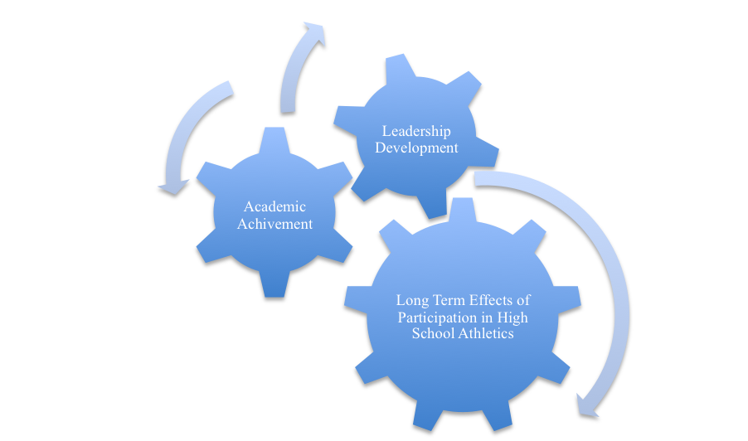

Figure 1 is a graphic representation demonstrating that the long-term effects of participation in high school athletics as a driving force that directly impacts academic achievement and leadership development. The long-term effects of high school athletics is represented as a main gear generating the energy and force that promotes two smaller gears representing academic achievement and leadership development. Without the driving force behind the long-term effects of high school athletics, academic achievement and leadership development provide a much limited force.

Research Questions
As school districts across the United States and in particular the State of Wisconsin are forced to deal with budget reductions, one of the areas that multiple districts are looking to make cuts is in the area of high school athletics. Are high school athletics an area that school districts should look at reducing to save money, or do the long-term effects of high school athletics make them an invaluable investment in our future? Therefore, an in-depth look at the following questions was considered:
What are the long-term effects of participation in high school athletics?
- Does participation in high school athletics affect academic achievement?
- Does participation in high school athletics affect leadership development?
Other questions may arise, but those are the questions that established the framework for this particular study and may create an opportunity in the future for others to conduct research relating to other long-term effects of participation in high school athletics.

CHAPTER 2

REVIEW OF THE LITERATURE

Introduction
According to the U.S. Department of Education (2002), since the inception of The No Child Left Behind Act in 2001, a landmark in education reform designed to improve student achievement across America’s schools, increased pressure has been placed on school districts to increase test scores to meet Annual Yearly Progress and avoid the dreaded title of being a failing school. President George W. Bush called the No Child Left Behind Act “the cornerstone of my administration,” and during his first week in office in January of 2001 stated, “These reforms express my deep belief in our public schools and their mission to build the mind and character of every child, from every background, in every part of America” (p. 9).
The National Federation of State High School Associations (2008) indicated that a major factor in building the mind and character of American children regardless of race, gender, and social economical background is participation in co-curricular activities such as high school athletics. These goals are clearly embedded within the mission statement of the National Federation of State High School Associations (2008) stating that:
- Interscholastic activity programs including high school athletics enrich each student’s educational experience.
- Interscholastic activity programs including high school athletics foster involvement of a diverse population.
- Interscholastic activity programs including athletics promote positive school/community relations.
These co-curricular opportunities for students of both genders are ensured through Title IX of the Educational Amendments of 1972. According to About Title IX (2009), this landmark legislation bans sex discrimination in schools, whether it be in academics or athletics and states:
“No person in the U.S. shall, on the basis of sex be excluded from participation in, or denied the benefits or, or be subjected to discrimination under any educational program or activity receiving federal aid.”
In a study conducted by Broh (2002), a conclusion was drawn that participation in interscholastic high school sports has multiple benefits for students of both genders. The researcher conducted an analysis of high school athletics using an ordinary least squares (OLS) analysis to find if participation in high school athletics affected test scores and grades for student athletes between their sophomore and senior year of high school in addition to finding if there are personal and social benefits as well between their sophomore and senior year in high school. The data for this research came from NELS: 88, a nationally representative, longitudinal study sponsored by the National Center for Education Statistics (NCES) from the United States Department of Education.
Broh (2002) found that grades for student athletes between their sophomore and senior year did get better and that these student athletes significantly improved self-esteem, time devoted to homework, and an increase in athletes’ number of academically oriented friends. The researcher also found that participation in high school athletics greatly increased social ties between students and the school and students and parents, parents and the school, and parents to parents. These participants in high school athletics also increased contact with parents outside of class, the amount of time that they talked with their parents about issues related to school, and how much parents had contact with the school.
Holloway (1999-2000) indicated that instead of cutting co-curricular programs such as high school athletics when faced with budget squeezes, school districts might find that these activity programs are worth their weight in gold because they help students stay in and succeed at school. A conflict exists between raising academic expectations of a school district often times associated with standardized test scores and continued cuts to the budgets of school districts across the United States. Holloway also found that any notion of cutting athletic programs in order to maintain academic programs might actually create more problems than actual solutions.
In a review of the literature conducted by Stevens and Peltier (1994), the researchers found the outcomes of participation in extra-curricular activities such as high school athletics provided a positive social network established by young adults in an increasingly difficult time in their lives. High school sports appear to develop self-esteem, self-confidence, and maturity among participants as it provides an opportunity for enhanced perseverance, leadership, and responsibility. Kuga and Douctre (1994) confirmed these findings and noted that participation in high school athletics also leads to a positive impact on sociological gains in self-image. While the standardized test score craze that continues to sweep across our nation fails to measure areas such as these, it is evident nevertheless that there is a positive impact high school athletics has on the overall development of individuals.
It is interesting to note that several of the characteristics listed above are used as criteria for induction into the National Honor Society, one of the most recognized high school organizations in nation for scholarship, leadership, and service. According to the Official Site of the National Honor Society (2009), the organization seeks to recognize several of these very same characteristics as it recognizes outstanding high school students. Membership in this premier organization is based on recognizing students that have challenged themselves through active involvement in school activities and community service.
Marsh and Kleitman (2003) found that students who participated in high school athletics had higher grades, higher self-esteem, higher educational aspirations, spent more time on homework, applied to more universities, and experienced higher parental expectations. Marsh and Kleitman also found that total athletic participation had positive effects on university enrollment, months enrolled in a university, and educational aspirations. The researchers went even a step further stating that they strongly recommended that schools retain athletic programs and even develop more exciting athletic programs despite the fact that many schools are facing financial problems and budget cuts.
In another study by Marsh and Kleitman (2002), the researchers recommended that policymakers seek to broaden extracurricular sports activity options available to students, including activities that do not specifically focus on academic outcomes, such as athletics. In times of tight educational budgets, it is particularly important that cost-cutting measures do not force schools to eliminate co-curricular activities such as high school athletics.
Lipscomb (2005) however pointed out that high school athletics also may force student athletes to sacrifice time previously focused on human capital acquisition and thereby negatively affecting student outcomes. Lipscomb also stated there is a need to understand more about this relationship before drawing conclusions about how schools should allocate their resources and how students should allocate their time.
A study conducted by Hunt (2005) also raised an interesting question as it indicated both (a) the effects of participation in extracurricular activities, including high school athletics, had on academic outcomes and (b) the effects of academic outcomes on participation in extracurricular activities such as high school athletics. Rather than students’ participation leading to higher levels of academic outcomes, the research indicated the level of academic achievement may lead to students engaging in activities such as high school athletics.

High School Athletics and Academic Achievement
In their review of literature, Cairns, Farmer, and Mahoney (2003) found numerous studies alluding to both immediate and long-term educational benefits and academic achievement associated with participants in high school athletics. Similarly, Barber, Eccles, and Stone (2001) found students that participated in high school athletics not only had higher grade-point averages in high school than those students that did not participate in high school athletics, but were also more likely than nonparticipants to enroll in college as a full time student. Students that participated in high school athletics were also more likely than students that did not participate in high school athletics to earn a bachelor’s degree (National Center for Education Statistics 2005, Lipscomb 2005).
Reducing the percentage of students dropping out of high school may be another benefit to athletic participation. Engagement in co-curricular activities such as high school athletics decreases the rate of early dropout from high school due in part to the fact that students involved in high school athletics are more highly committed and have a greater attachment to the school (Black, 2002).
Greene (2002) pointed out in his study the bleak future that faces students who fail to graduate from high school. Students that do not graduate from high school and receive the skills that are essential for success in today’s economy are likely to suffer with significantly reduced earning and employment prospects. Greene also found that in the 1999 Population Survey of the U.S. Census the median earnings, if any earnings were reported at all, for individuals over 25 years of age without a high school diploma or GED was $15,334 compared to $29,294 for individuals over 25 years of age with at least a high school diploma or GED.
Greene (2002) also found that students who fail to graduate from high school are also significantly more likely to become single parents and have children at young ages and are significantly more likely to rely upon public assistance or be in prison. High school graduation is a very important predictor of future prospects. Since participation in high school athletics reduces the percentage of students dropping out of high school, and the negative impacts associated with high school dropouts, this information only lends more support for the importance of maintaining and enhancing participation in high school athletics.
Cairns, Farmer, and Mahoney (2003) conducted a study of 364 girls and 331 boys that were living in the southeastern United States. The students were tracked annually from the fourth through twelfth grade, with an exit interview around twenty years of age. The researchers found that consistent activity participation was linked to high educational aspirations at late adolescence and participation in co-curricular activities did afford opportunities to build interpersonal skills and construct positive plans for the future associated with high educational status at young adulthood.
In using data from the National Longitudinal Study of Adolescent Health, Videon’s (2002) study suggested a positive association between participation and all of the academic outcomes meaning that participation in athletics might positively influence adolescents’ academic outcomes. Anderson (1998) supported this conclusion through a study that found high school athletes were less likely to drop out of school than non-athletes. The study also noted a positive correlation between participation in athletics and educational attainment through college.
On the contrary, Eide and Ronan (2001) found evidence that sports participation had a negative effect on the educational attainment of white male student athletes, and no effect of participation on the educational attainment or earnings of Hispanic males or black and Hispanic females. The study did however find a positive effect on the educational attainment and earnings of black male student athletes and a positive effect on the educational attainment of white female student athletes.

High School Athletics and Leadership Development
Long-term influences of athletic participation in high school may improve leadership skills and enhance an individual’s economic status. Studies suggest there may be a positive relationship between individuals that participated in high school athletics and their future economic status and employability. The National Center for Educational Statistics (2005) indicated that high school athletes experienced greater labor market success than students that did not participate in high school athletics.
A study by Dobosz and Beaty (1999) found that high school athletes demonstrated significantly greater leadership ability than non-athletes and provided evidence that participation in high school athletics may increase and strengthen leadership potential. These researchers defined leadership as an ability to lead others toward the attainment of a common goal and stated that decisiveness, determination, interpersonal and organizational aptitude, loyalty, self-efficacy, and self-discipline are just some of the characteristics needed to be an adequate leader.
Dobosz and Beaty (1999) randomly selected 30 athletes and 30 non-athletes from a public high school in the western suburbs of Chicago with an enrollment of over 1,000 students that is considered a college-preparatory high school. The researchers used a 50-item Leadership Ability Evaluation designed to measure leadership skills. Through their findings Dobosz and Beaty found that high school athletics is a way for students to enhance characteristics of an effective leader, and even went on to state that it is essential that school boards and administration take an in-depth look at budget threats relating to high school athletics, since developing skills necessary to be an effective leader is a goal of the educational system. Therefore, since participation in high school athletics develops leadership skills, it is strongly recommended that athletic programs be properly maintained.
Leadership experiences built through high school athletic participation also lead individuals into managerial positions, thus having a positive effect on their salaries as an adult (Kuhn & Weinberger, 2005). Barron, Ewing, and Waddell’s (2000) study indicated that men at an average age of 32 who had participated in high school athletics were paid 31% higher wages than those who had not participated. A similar study conducted by Curtis, McTeer, and White (2003) found that individuals that participated in organized sports tended to have higher annual earned incomes as adults than those who did not participate.
A review of the literature indicated that there are long-term positive effects associated with participation in high school athletics. The research has cited numerous studies indicating that some of the positive effects associated with participation in high school athletics include (a) higher grade point averages (Barber, Eccles, & Stone 2001; Marsh & Kleitman, 2003), (b) more likely to enroll in college as a full-time student and earn a bachelor’s degree (National Center for Education Statistics, 2005; Lipscomb, 2005), (c) decrease the rate of early dropout in high school (Black 2002; Anderson, 1998), (d) greater attachment and commitment to a school community (Black 2002; Anderson, 1998), (e) future economic status (Kuhn & Weinberger, 2005; Barron, Ewing, & Waddell, 2000; Curtis, McTeer, & White, 2003), and (f) greater labor market success (Greene, 2002).
On the contrary, two studies were found that contradicted the majority of the information found by this researcher. Lipscomb (2005) stated concerns over the amount of time dedicated to athletics and that it may force student athletes to sacrifice time previously focused on human capital acquisition, potentially negatively affecting student outcomes. Eide and Ronan (2001) also found that participation in high school athletics may lead to a negative effect on the educational attainment of some individuals.
Gaps in the literature include a lack of academic research and discussion on whether or not there are long-term health effects for individuals that participated in high school athletics or if individuals that participated in high school athletics lead a healthier lifestyle. There was a gap in the literature regarding whether or not there were long-term effects of participation in high school athletics relating to an increased level of community involvement and volunteering as adults. A further study in this area may be of benefit.

CHAPTER 3

METHODOLOGY

Design
The intention of this study was to explore the long-term effects associated with participation in high school athletics. As school districts across the United States continue to be forced to make budget cuts, pressures continue to build on schools to raise tests scores on a continually decreasing budget. School districts are continually being forced to make difficult decisions on where these limited resources need to be spent.
Often, athletics are perceived to be something extra in our high schools and are one of the first programs to be cut in times of budget reductions. Are high school athletics just extra-curricular activities, or would they better be described as co-curricular activities? The intent of this study was to explore the question, “Are there long-term effects of participation in high school athletics?” Along with this main question, two ancillary questions were established through the review of literature:
- Does participation in high school athletics affect academic achievement?
- Does participation in high school athletics affect leadership development?

Orientation
The research conducted for this study was a mixed methodology that is both quantitative and qualitative in nature. It was quantitative in nature since a Likert-type scale was used to gather data for the research. The research was also qualitative in nature since it was taking an in-depth look at perceptions regarding the long-term effects of high school athletics and contained open-ended questions to a survey. The study was reviewed and approved by the Edgewood College Human Participants Review Board during the summer of 2008. The HPRB approval letter can be found in the Appendix.

Data Sources
As stated in the Review of Literature, Nardi (2003), Mertens (1998), and Neuman (2006) proved to be valuable resources as a means of using a survey approach over other potential data gathering devices. A decision was made with the help of the researcher’s cohort members at Edgewood College that individuals that graduated 15 years prior would allow for enough time to determine if there are long-term effects associated with participation in high school athletics. After reviewing and updating several drafts of the questionnaire with two other individuals in the researcher’s cohort, a survey was conducted to determine what perceptions exist regarding the long-term effects of participation in high school athletics. This survey was mailed to the 1993 graduating class of Cuba City High School. A self addressed stamped envelope was mailed with the surveys.
Cuba City High School is located in Cuba City, a small rural community in Southwestern Wisconsin and 19 miles east of Dubuque, Iowa. Cuba City was founded in 1875, and currently has maintained a very steady population over the past three decades of just over 2,000 citizens.
The community of Cuba City takes great pride in the academic and athletic success of its schools, and in particular the high school provides a strong sense of identity for the community. This is evident from the Cuba City School District Website (2008) stating, “The Cuba City District, in partnership with our families and communities, is dedicated to developing responsible citizens who are well prepared for future opportunities. We want each student to reach his or her fullest potential through a challenging education with real life experience.”
As Cuba City High School strives to live up to the academic expectations within its mission statement, it is probably best known throughout the State of Wisconsin for its success in athletic competition. As an individual would walk through the south entrance of Cuba City High School that was newly renovated in 2005, one would pass a trophy case before entering a spotless gymnasium named after the coach with the most wins in the history of boys’ basketball in the State of Wisconsin, Jerry Petitgoue. While it is very common for a high school to have a trophy case just outside of its gymnasium, there is something that separates this trophy case from other high schools in that it spans nearly 20 yards and is filled only with State championship trophies. During their four years in high school, the graduating class of 1993 was a part of three state championships in both volleyball and girls’ basketball to go along with one state championship in boys’ basketball. This is not taking into account that while in high school, conference championships were won all four years in volleyball, girls’ basketball, and boys’ basketball. Baseball also found itself on top of the conference on three different occasions during this four-year span. A conference championship was also won in football and wrestling during this time frame.
It is the belief of the researcher that the nearly unprecedented athletic success over this four year window that the 1993 graduating class of Cuba City experienced will provide a valuable in-depth look at the long-term effects of participation in high school athletics.

Data Collection
The survey used to gather data was a Likert-type survey with questions regarding perceptions of the long-term effects of participation in high school athletics. The answers on the scale ranged from 1 (strongly disagree) to 4 (strongly agree). The survey also contained two open-ended questions to which the participants could respond in their own words. The survey was mailed to all of the 1993 graduates of Cuba City High School and returned by mail to an administrative assistant in the Scales Mound School District #211 Office. The surveys were kept in a safe in the Scales Mound School District Office when they were not being used to tabulate results.

Data Management and Analysis
Once the surveys were collected, the survey data were managed using the functions available in Microsoft Excel. The functions on Microsoft Excel were used to display the analysis and graphs. The data from the surveys were used to investigate the impact that high school athletics had on the academic achievement and leadership development of the participants. The data were also used to investigate how the long-term impact on participation in high school athletics potentially varied between females and males. While the potential difference in responses by female and male respondents was not core to this research, it was easily obtainable and may prove beneficial to future research.
Data were also used to investigate if former high school athletes that participated in multiple sports over multiple years demonstrated a more significant impact on academic achievement and leadership development. Through the use of Microsoft Word, an in-depth written analysis was made of the data collected. The surveys were kept confidential and were assigned a number as they were returned for organizational purposes only. Once the dissertation was published, the surveys were destroyed by a shredding machine in the Scales Mound School District Office.

Limitations to the Study
One of the main limitations to this study was the narrowed environment and sample size of the population. The perception of the individuals included in this survey may not give an accurate assessment of the potential long-term effects of participation in high school athletics due to the participants in the survey having graduated in the same year from the same school district. This study also did not take into account the potential long-term effects of high school athletics on individuals that graduated from high school more than fifteen years prior.
Another potential limitation may be that the participants in the study know the individual conducting the research and thus may skew their responses to what they feel the researcher may be trying to gather rather than offering a completely honest response.

CHAPTER 4

FINDINGS

Review of the Plan
This research was conducted during the summer and through the fall of 2008. The research included a survey of 10 questions designed to elicit information regarding perceptions on the long–term effects of high school athletics from individuals that graduated from high school 15 years prior. The survey also included five questions regarding background data and two open-ended response questions. The background information pertaining to the level(s) of athletic completion that the respondent participated in while in high school, and the background information pertaining to whether or not the respondent made the Honor Roll on one or more occasions while in high school was not incorporated into the study. The background information questions that referenced gender, the total number of seasons that the respondent participated in high school athletics, and whether or not the individual completing the survey was inducted into the National Honor Society while in high school provided the necessary information for the researcher to adequately complete the study.

Review of Research Procedures
The survey results were obtained by contacting classmates of the researcher from the Cuba City High School graduating class of 1993 through the mail. There were a total of 74 graduates from Cuba City High School in 1993, and 65 of those graduates were mailed the survey.
The reason for nine of the graduates not being contacted includes the fact that two of the graduates have since died, one of the graduates did not fill out the survey as the researcher, and six of the graduates’ addresses could not be located. Thirty-six of the 65 surveys were returned to the researcher representing a return rate of 55%. Of the 36 surveys that were returned 19 of the respondents were females and 17 of the respondents were males. One of the female and one of the male respondents indicated that they did not participate in high school athletics and were not included in this study. Of the 18 females that responded to the survey and participated in high school athletics 10 of these former student athletes were inducted into the National Honor Society. Of the 16 males that responded to the survey and participated in high school athletics 5 of these former student athletes were inducted into the National Honor Society.

Review of the Research Questions
This research was initiated to examine any long-term effects of participation in high school athletics. Specifically, the research looked to address the following two questions:
- Does participation in high school athletics affect academic achievement?
- Does participation in high school athletics affect leadership development?

Evidence Regarding the Research Questions
The first three questions in the survey applied to the question “Does participation in high school athletics affect academic achievement?” The other seven questions on the survey applied to the research question, “Does participation in high school athletics affect leadership development?” This information was used to analyze a potential relationship between high school athletics and academic achievement and/or leadership development.
Figure 2 illustrates the average response for each of the ten survey questions on a Likert-type scale with a response of a 1 indicated a strong sense of disagreement about the given statement, a response of a 2 indicated that the individual completing the survey somewhat disagrees with the statement. A response of a 3 on the survey indicated that the individual completing the survey somewhat agreed, and a 4 indicated a strong sense of agreement with the survey statement.
Figure 2. Average Responses to 10 Survey Questions

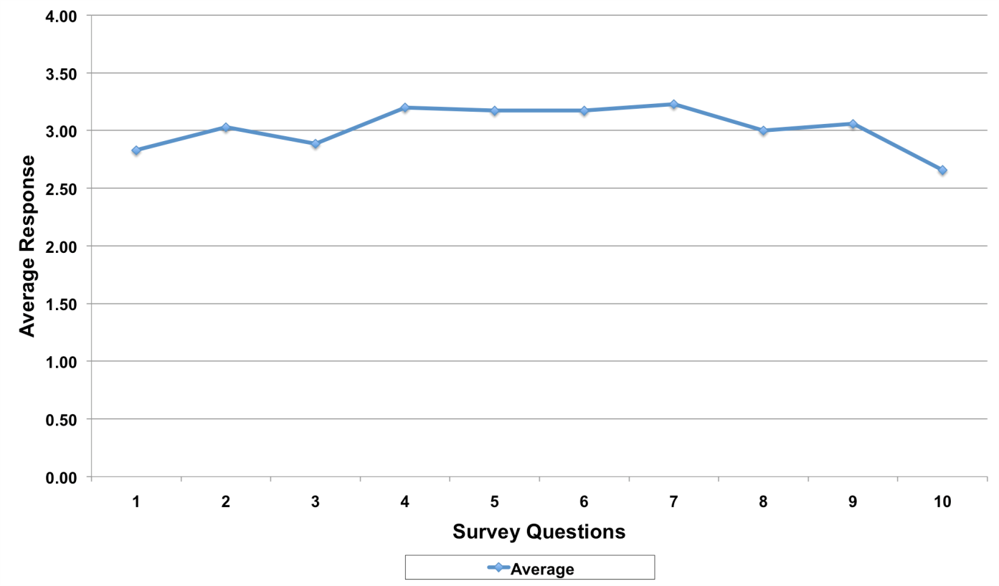

The overall average response to the questions on the survey was 3.02. Questions 1-3 on the survey focused on the long-term effects of participation in high school athletics on academic achievement and questions 4-10 on the survey focused on the long-term effects of participation in high school athletics on leadership development.
The average response for questions 1-3 representing academic achievement was 2.92. This positive perception of students that participated in high school athletics was especially strong in the responses to question number 2, “Participation in high school athletics helped me develop skills that contributed to earning better grades.” The average answer for this response was 3.03. While the perceptions of the respondents that participated in high school athletes still indicated a positive connection with question one, “Participation in high school athletics led to higher parental expectations of me as a student,” with an average response of 2.83.
The average response for questions 4-10 representing leadership development was 3.07. The average respondent indicated that high school athletics did play a positive role in the lives of student athletes in regard to academic achievement and leadership development for every one of the ten questions asked in the survey, with the highest average of 3.23 associated with question 7, “Participation in high school athletics has helped me develop a stronger sense of perseverance throughout my life.” While the average response to question number 10, “Participation in high school athletics has helped me develop skills that contributed to a promotion in my place of employment” still indicated that the respondents were in agreement with this statement; it did have the lowest average response at 2.66.

National Honor Society Members and Non-Members
Figure 3 is a graph illustrating the average responses of individuals that were members of the National Honor Society compared to individuals that were not members of this organization. Questions 1-3 on the survey focused on the long-term effects of participation in high school athletics on academic achievement and questions 4-10 on the survey focused on the long-term effects of participation in high school athletics on leadership development.
Figure 3. Average Responses of Former Student Athletes Inducted Into the National Honor Society Members and Former Student Athletes Not Inducted Into the National Honor Society
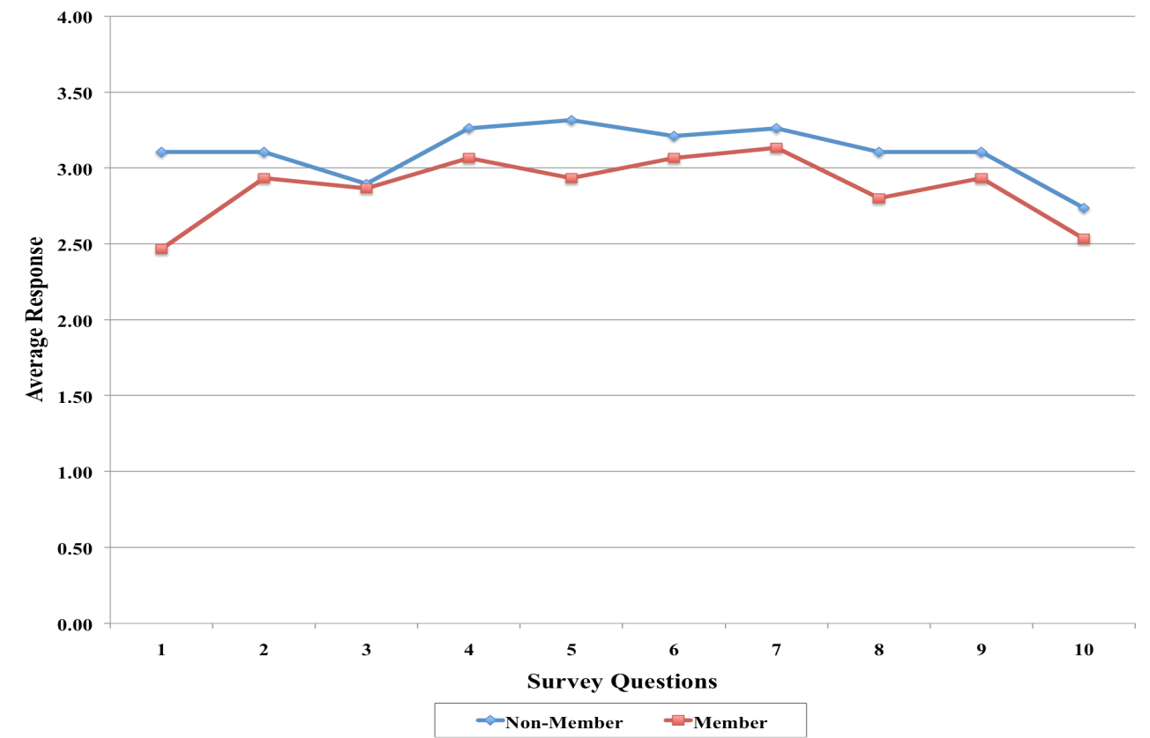

The average response for individuals that participated in high school athletics that were in the National Honor Society was lower for all ten questions of the survey than those student athletes that were not members of the National Honor Society. On average, student athletes that were not members of the National Honor Society perceived the benefits of participation in high school athletics to be greater than the individuals that participated in high school athletics and were members of the National Honor Society. In fact, the average response to question number one stating, “Participation in high school athletics led to higher parental expectations of me as a student,” indicated a stronger sense of disagreement than agreement with this statement with an average response of 2.47. This was the only question in comparing the two groups that the average response did not indicate a positive perception.
Overall, the average response for former student athletes that were not inductees of the National Honor Society was 3.11 compared to an average response of 2.87 for former student athletes that were inducted to the National Honor Society.
The greatest discrepancy between students that participated in high school athletics that were not inducted into the National Honor Society and those student athletes that were inducted into the National Honor Society occurred on question number one stating, “Participation in high school athletics led to higher parental expectations of me as a student,” where the average response for non-members of the National Honor Society was 3.11 compared to 2.47 for members of the National Honor Society.
The smallest discrepancy between former student athletes that were not members of the National Honor Society and former student athletes that were inducted into the National Honor Society was in question number 3 stating, “Participation in high school athletics helped me develop higher educational aspirations as a student,” where the average response for individuals that participated in high school athletics that were not inducted into the National Honor Society was 2.89 compared to 2.87 for individuals that participated in high school athletics and were also inducted into the National Honor Society.
In focusing on the long-term effects that high school athletics has on academic achievement, former student athletes that were non-members of the National Honor Society perceived that there were positive long-term effects of participation in high school athletics for all of the survey questions associated with academic achievement with an average response of 3.04 in this category. Student athletes that were not members of the National Honor Society were most in agreement with question number 1 on the survey stating, “Participation in high school athletics led to higher parental expectations of me as a student, and question number 2 stating, “Participation in high school athletics helped me develop skills that contributed to earning better grades,” with an average response of 3.11 for both questions on the survey. The lowest average response regarding the long-term effects of academic achievement was to question number 3 stating, “Participation in high school athletics helped me develop higher educational aspirations as a student,” with an average response of 2.89.
Regarding the long-term effects of participation in high school athletics on academic achievement, the average response for students that participated in high school athletics and were inducted into the National Honor Society was 2.76 in this category. National Honor Society members were in agreement with questions number 2 stating, “Participation in high school athletics helped me develop skills that contributed to earning better grades,” with an average response of 2.93. As stated before, those students that participated in high school athletics and were members of the National Honor Society responded with a greater sense of disagreement than agreement on question number 1 of the survey stating, “Participation in high school athletics led to higher parental expectations of me as a student,” with an average response of 2.47. Once again, it is interesting to note that this is the only question when comparing the two groups in which there was not a positive perception regarding the long-term effects of participation in high school athletics. This is also the question on the survey in which there was the greatest level of difference in perceptions between former student athletes that were not in the National Honor Society and former student athletes that were in the National Honor Society.
In regard to former student athletes that were not inducted into the National Honor Society and their perceptions on how participation in high school athletics impacted leadership development, student athletes that were non-members of the National Honor Society perceived that there were positive long-term effects of participation in high school athletics for all of the survey questions associated with leadership development with an average response of 3.14 in this category. Students that participated in high school athletics that were not National Honor Society Members were most in agreement with question number 7 on the survey stating, “Participation in high school athletics has helped me develop a stronger sense of self-esteem throughout my life,” with an average response of 3.32. The lowest average response regarding the long-term effects of leadership development was in regards to question number 10 on the survey stating, “Participation in high school athletics has helped me develop skills that contributed to a promotion in my place of employment,” with an average response of 2.74.
The average response for former student athletes that were inducted into the National Honor Society regarding the long-term effects of participation in high school athletics on leadership development was 2.92. These former student athletes were in greatest agreement with question number 7 stating, “Participation in high school athletics has helped me develop a stronger sense of perseverance throughout my life,” with an average response of 3.13 for this question. The lowest level of agreement from the former student athletes that were members of the National Honor Society was with question number 10 stating, “Participation in high school athletics has helped me develop skills that contributed to a promotion in my place of employment,” with an average response of 2.53.

Seasons Participated in High School Athletics

Figure 4 represents the average response of former student athletes based on the number of seasons that they participated in high school athletics. These former student athletes were broken into categories based on 1-4, 5-8, 9-12, and 13-16 seasons that they participated in athletics while in high school.
Figure 4. Average Response by Seasons Individuals Participated in High School Athletics
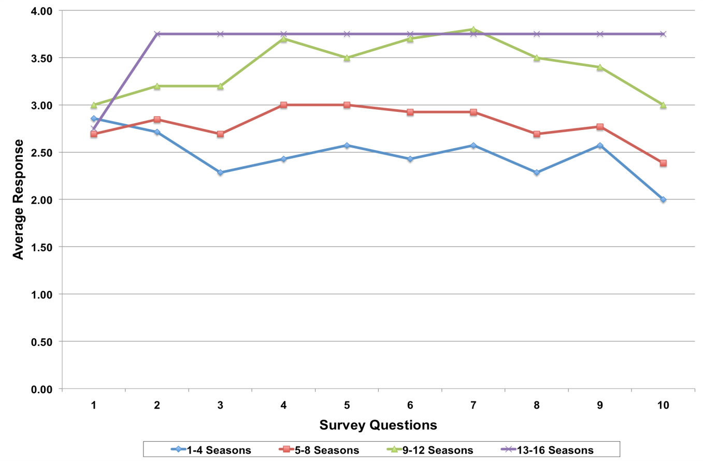

These findings are relatively consistent in the fact that the more seasons student athletes participated in high school athletics, the higher the average response was to the survey questions relating to academic achievement and leadership development. The main exception to this general pattern was the first statement on the survey stating, “Participation in high school athletics led to higher parental expectations as a student.” Question number 7 stating, “Participation in high school athletics has helped me develop a stronger sense of perseverance throughout my life,” was the only other question on the survey in which there was a variation from the pattern in which the more seasons that a student athlete participated in high school athletics the higher the average response to the given question. On this question, former student athletes that participated in high school athletics 9-12 seasons had an average response of 3.80 compared to an average response of 3.75 for former student athletes that participated in 13 or more seasons of high school athletics.
When taking a closer look at the averages for academic achievement and leadership development, the more seasons that a student athlete participated in high school athletics, the greater the perceived benefit of high school athletics. The overall average response for student athletes that participated in 1-4 seasons was 2.47, 5-8 seasons was 2.79, 9-12 seasons was 3.40, and 13 or more seasons 3.65.
While there was a balance in the number of seasons that females and males participated in 1-4, 5-8, and 9-12 seasons, it is important to note at the time that the participants in this study were in high school, the boys’ baseball season was during the summer months and the girls’ softball was during the spring. While boys’ baseball season has since been changed to coincide with girls’ softball during the spring, at the time the respondents to this survey were in high school boys were given an opportunity to participate in high school athletics during the fall, winter, spring, and summer (16 seasons) and girls’ were only able to participate in high school athletics during the fall, winter, and spring (12 seasons) even though there were the same number of athletic teams for girls and boys. Only 4 males that responded to the survey participated in 13-16 seasons.
In regard to academic achievement, the average response for student athletes that participated in high school athletics 1-4 seasons was 2.62, 5-8 seasons was 2.74, 9-12 seasons 3.13, and 13 or more seasons 3.42. The responses for the questions on the survey pertaining to leadership development followed the same pattern with the average response for former student athletes that participated in high school athletics 1-4 seasons 2.41, 5-8 seasons 2.81, 9-12 seasons 3.51, and 13 or more seasons 3.75.
Additional Findings
Figure 5 illustrates the difference between the perceptions of males and females that participated in high school athletics. Questions 1-3 on the survey focused on the long-term effects of participation in high school athletics on academic achievement and questions 4-10 on the survey focused on the long-term effects of participation in high school athletics on leadership development.
Figure 5. Average Response of Former Female and Male Student Athletes
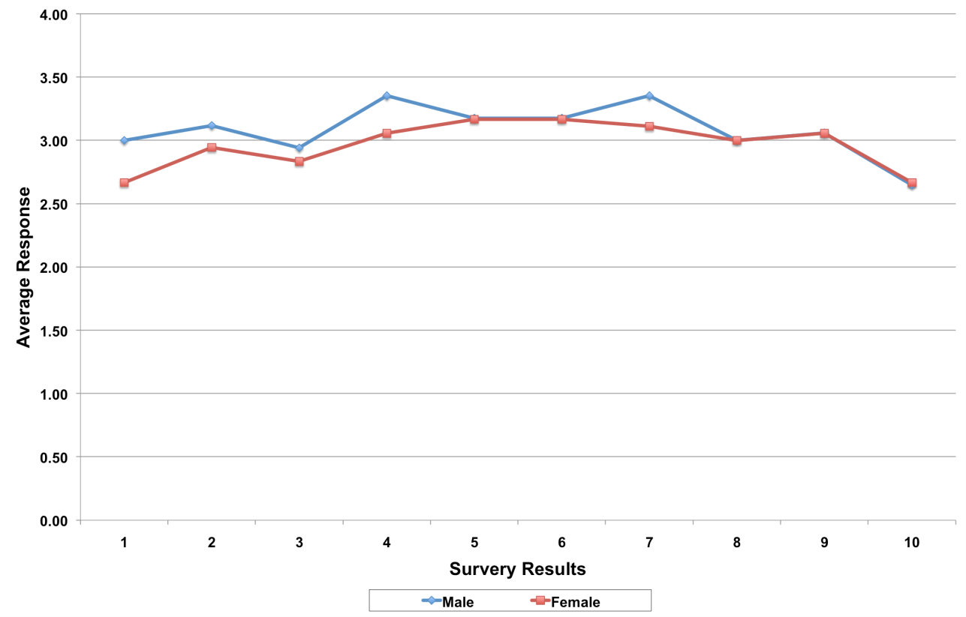

Former male student athletes perceived the benefits of participation in high school athletics to be greater than females that participated in high school athletics with an average response of 3.08 for former male student athletes compared to 2.97 for former female student athletes. The only survey question that former female student athletes found the long-term effects of participation in high school athletics to have a greater impact than males that participated in high school athletics is question number 10 stating, “Participation in high school athletics has helped me develop skills that contributed to a promotion in my place of employment.” The question on the survey with the greatest difference between the perceptions of females and males that participated in high school athletics was question number 1 stating, “Participation in high school athletics led to higher parental expectations of me as a student,” where the average response for females was 2.67 compared to 3.00 for males.
In focusing on the long-term effects that high school athletics has on academic achievement, female student athletes perceived that there were positive long-term effects of participation in high school athletics for all of the survey questions associated with academic achievement with an average response of 2.81 in this category. Females that participated in high school athletics were most in agreement with question number 2 on the survey stating, “Participation in high school athletics helped me develop higher educational aspirations as a student,” with an average response of 2.83. While former female student athletes were still in agreement with the following survey question, the lowest average response regarding the long-term effects of academic achievement was to question number 1 stating, “Participation in high school athletics led to higher parental expectations of me as a student,” with an average response of 2.67.
Regarding the long-term effects of participation in high school athletics on academic achievement, the average response for male student athletes was 3.02 for this category. Like females that participated in high school athletics, former male student athletes were in greatest agreement with question number 2 on the survey stating, “Participation in high school athletics helped me develop higher educational aspirations as a student,” with an average response of 3.12. Former male student athletes had the lowest level of agreement in the portion of the survey relating to academic achievement with question number 3 stating, “Participation in high school athletics helped me develop higher educational aspirations as a student,” in which the average response was 2.94.
In regard to former female student athletes and their perceptions on how participation in high school athletics impacted leadership development, females that participated in high school athletics perceived there were positive long-term effects of participation in high school athletics for all of the survey questions associated with leadership development with an average response of 3.03 in this category. Females that participated in high school athletics were most in agreement with question number 5 on this portion of the survey stating, “Participation in high school athletics has helped me develop a stronger sense of self-esteem throughout my life,” and question number 6 on this section of the survey stating, “Participation in high school athletics has helped me develop a stronger sense of self-confidence throughout my life,” in which both responses solicited an average response of 3.17. The lowest average response regarding the long-term effects of leadership development was to question number 10 on the survey, “Participation in high school athletics has helped me develop skills that contributed to a promotion in my place of employment” with an average response of 2.67.
The average response on the survey for former male student athletes regarding the long-term effects of participation in high school athletics on leadership development was 3.11. Former male student athletes were in greatest agreement with question number 4 on the survey stating, “Participation in high school athletics has helped me become a more responsible person throughout my life,” and question number 7 on the survey stating, “Participation in high school athletics has helped me develop a stronger sense of perseverance throughout my life,” with an average response of 3.35 for both of these questions. The lowest level of agreement from former male student athletes to leadership development was associated with question number 10 stating, “Participation in high school athletics has helped me develop skills that contributed to a promotion in my place of employment,” with an average response of 2.65. The response from females that participated in high school athletics on this question of the survey was 2.67 which, as stated before, was the only question on the survey in which female student athletes had a greater level of agreement with a given question than males that participated in high school athletics.

Open-Ended Responses
In regard to the open-ended responses to the survey, there were three main themes that evolved regarding the question, “What additional qualities have you developed as a person based on your participation in high school athletics?”
The first of these themes that separated itself among the rest was the ability to work together with others including teamwork as a social skill. The following comments, shared from former student athletes, exemplify this theme:
- “I discovered the importance of depending on one’s teammates.”
- “I think the biggest impact sports had on me was how to work effectively as a team on the job.”
- “Sense of responsibility to my teammates (team or work).”
- “I formed certain bonds with my teammates that was [sic] important to my development in interacting with other individuals in life and the workplace.”
- “I developed the ability to work together as a team.”
- “I developed a general level of higher expectations of myself and fellow teammates, i.e., co-workers.”
- “Ability to accept constructive criticism and the importance of depending on one’s teammates.”
The second most common theme that emerged from the open-ended portion of the survey was the lasting impact that participation in high school athletics played in the overall physical well-being of these former student athletes. The following comments were shared on this portion of the survey:
- “Our society is getting to be one of a sedentary lifestyle. Without extra-curricular athletics, who will make young adults stay active enough to shed the calories that many of us over consume daily? Physical education class isn’t enough.”
- “Another advantage is that sports teach kids that exercise is important. In order to be a strong player you need to have a strong body and I know I have carried this through my life so far. Being physically active is an important thing to maintain a healthy lifestyle.”
- “I developed a love for running and lifting weights – still do both.”
- “I don’t think I would have the active lifestyle I do now without athletics in high school – in a time of rising obesity and being overweight, this is an invaluable skill.”
- “An understanding on how to keep fit both mentally and physically. A healthy body leads to a healthy mind.”
The third most common theme that emerged from the data provided through answers and comments from the open-ended questions on the survey related to an increased sense of responsibility and discipline that contributed to strengthening the work ethic of those that responded to the survey and participated in high school athletics as evident through the following responses and comments to the two open ended questions on the survey.
- “It helped me develop my work ethic and strive to be the best at what you do.”
- “I developed discipline, determination and a habit of setting higher goals for myself. Not only were sports a breeding ground for discipline, self-esteem, higher goals and expectations, but I feel that some of the great coaches along the way were essential to the foundation of my life-long work ethic and determination to set high goals and excel in a career. Many of the leadership qualities and positions I’ve had, I can trace back to the confidence that a court leader gave me. To deny our children of these life lessons and emotions of both winning and losing would only deny them the advantages we had.”
The following comments were also given as answers to the open-ended portion of the survey that speak strongly to the positive impact that high school athletics played in the lives of several individuals completing the survey:
- “Things in life that may seem to be a failure at the time are often the things that will make bring you strength later in life.”
- “High school athletics made me into the person I am today. I excelled in them and I continue to excel in life because of them.”
- “I learned that things may not always go as you would like, but with determination and dedication you can achieve any goal. This works for your career and also when participating in sports.”
- “Cooperation, communication skills, leadership, problem solving, peer bonding, community pride. I played high school athletics, I watch high school athletics, and I coach high school athletics [sic] there is nothing like it!”
While the majority of the feedback on the Likert-type survey and open-ended response questions indicated positive perceptions on the long-term effects of participation in high school athletics, there were a few responses to the open-ended portion of the survey that indicated a mixed response regarding the long-term effects of high school athletics.
- “I don’t believe that participating in sports had much bearing on the person I am. I played sports for the fun, relaxation and the release of stress associated with school. It was something I did with my friends. I did however develop a couple of new friendships that I otherwise would not have, friendships that are still viable today!”
- “While I believe athletics helped to enhance the skills, I think the true development of the skills stems from family life and upbringing. I think personal views on athletic participation can vary greatly based on the success of the teams. In general, people who were consistently on successful teams would have a positive view on how athletics impacted them. I do not think that being involved in athletics had any correlation to being on the honor roll or being inducted into the National Honor Society.”
- “People who would go out for sports already have these qualities. That might be the reason the person goes out for sports.”

Summary of Findings
The research indicated, on average, the respondents to the survey found the long-term effects of participation in high school athletics to be positive, especially regarding how participation in high school athletics positively affects academic achievement, and how participation in high school athletics affects leadership development. Males found that participation in high school athletics had a greater positive impact on them than females, even though both groups of student athletes found that it did positively affect their academic achievement and leadership development.
Students that were members of the National Honor Society did find high school athletics to have a positive impact on their lives regarding academic achievement and leadership development. Students that were not members of the National Honor Society found that the positive long-term effects of high school athletics were even greater in their lives. This may or may not be in contradiction to the fact that the more seasons that a student athlete participated in throughout their four years in high school, the more those student athletes found high school athletics to increase their academic achievement and leadership development, two characteristics of the National Honor Society.
In conclusion, the following findings emerged as a result of this research on the long-term effects of participation in high school athletics.
- Former student athletes that were not members of the National Honor Society perceived greater positive effects of participation in high school athletics in regard to academic achievement and leadership development than students that participated in high school athletics and were inducted into the National Honor Society.
- The more seasons that a former student athlete participated in high school athletics, on average, the greater the perceived positive effects of participation in high school athletics on academic achievement and leadership development.
- Former male student athletes had a positive perception on the long-term effects of participation in high school athletics on academic achievement and leadership development with an average response of 3.08.
- Former female student athletes also had a positive perception on the long-term effects of participation in high school athletics on academic achievement and leadership development even though the average response was not as high as the males that participated in high school athletics with an average response of 2.97.
- The perception of every group of individuals examined in this survey is that there are positive long-term effects to participation in high school athletics regarding academic achievement and leadership development.

CHAPTER 5

CONCLUSIONS AND RECOMMENDATIONS

Conclusions
This research began with a question regarding the long-term effects of participation in high school athletics. While not all of the evidence is conclusive, support certainly exists that there are long-term positive effects associated with participation in high school athletics, especially as it relates to academic achievement and leadership development.
The responses to the survey statements and open-ended questions in the research suggested the answer is positive; however, not all of the individuals that responded to the survey indicated that participation in high school athletics had a positive effect on their academic achievement and leadership development. On average, former student athletes that were members of the National Honor Society did not agree with the first question that related to academic achievement on the survey stating, “Participation in high school athletics led to higher parental expectations of me as a student.” The only other category of individuals that indicated a less than positive perception toward the long-term effects of high school athletics was a group of former student athletes that participated in 1-4 seasons of high school athletics. They did not agree with question number 3 on the survey stating, “Participation in high school athletics helped me develop higher educational aspirations as a student.” This particular category of individuals was also the only group to indicate a less than positive perception toward leadership development as a whole with an average response of 2.41 for this group of questions.

Academic Achievement
When considering the research question focusing on how high school athletics affect academic achievement, the respondents to the researcher’s survey, on average, indicated that high school athletics did indeed have a positive effect on academic achievement.
When comparing student athletes that were members of the National Honor Society to individuals that participated in high school athletics that were not members of the National Honor Society, there was a very interesting break down. While National Honor Society Members did find participation in high school athletics to have a positive impact on their academic achievement, student athletes that were not members of the National Honor Society found that participation in high school athletics had a greater impact on their academic achievement than students that were members of the National Honor Society.
The study also found that the more seasons that former student athletes participated in, the greater the impact on academic achievement. Once again, the only exception to this statement regarding academic achievement was in question number 1 stating, “Participation in high school athletics led to higher parental expectations of me as a student,” in which the pattern was not as clearly defined.
Both former male and female student athletes perceived the long-term effects of participation in high school athletics to be positive. Nevertheless, former male student athletes had a higher average response to every one of the survey questions associated with academic achievement than former female student athletes.
A conclusion drawn from this information is former male student athletes that completed the survey had the opportunity to participate in more seasons of athletic competition than the former female student athletes that completed this survey, they would have a greater opportunity to experience the positive impact found in this research that high school athletics has on academic achievement and leadership development.
The research also indicated that there are positive perceptions regarding the long-term effects of participation in high school athletics on academic achievement, and the more seasons that a former student athlete participated in high school athletics the greater the impact on academic achievement.
The research does lend itself to further exploration regarding why former student athletes that participated in high school athletics that were not inducted into the National Honor Society perceived a greater long-term impact on academic achievement than members of the National Honor Society, and why males that participated in high school athletics perceived a greater long-term impact on academic achievement than females that participated in high school athletics. Nevertheless, it was not the intent of the study to answer those questions, and it remains clear according to this study that there are positive long-term effects of participation in high school athletics on academic achievement for all categories examined in this research.

Leadership Development
Regarding the research question on how participation in high school athletics impacts leadership development, the individuals that responded to the survey found that participation in high school athletics did help them develop long-term leadership skills.
When comparing the perceptions regarding leadership development of National Honor Society members to the student athletes that responded to the survey that were not members of the National Honor Society, the results were consistent with the finding of the first research question regarding academic achievement. Student athletes that were not members of the National Honor Society found that participation in high school athletics had a greater impact on leadership development than students that were members of the National Honor Society, even though both groups of individuals found that participation in high school athletics did enhance their leadership development skills.
The more seasons that a student athlete participated in during their four years in high school, the greater the positive long-term impact it had on leadership development. The study led one to conclude that the more seasons a former student athlete participated in, the greater the perception that high school athletics helped these individuals become a more responsible, helped develop a stronger sense of self-esteem and self-confidence, mature as a person, helped develop skills that made them a better employee or self-employed worker, and helped develop skills that contributed to a promotion as an employee.
There was only one variation to this pattern, and it occurred on question number 7 stating, “Participation in high school athletics has helped me develop a stronger sense of perseverance throughout my life,” in which the average response to this question for former student athletes that participated in 9-12 seasons in high school athletics was 3.80 compared to an average response of 3.75 for former student athletes that participated in 13 or more seasons of high school athletics.
These results seem to contradict the responses of members of the National Honor Society. Members of the National Honor Society, an organization of academic achievers and leaders, did not find high school athletics to be as beneficial to them as student athletes that were not members of the National Honor Society. However, the more seasons that a student athlete participated in, the greater the positive long-term effects associated with academic achievement and leadership development.
The research also indicated that the positive effects on leadership development for males that participated in high school athletics were greater than that of female student athletes. The only exception to this was question number 10, “Participation in high school athletics has helped me develop skills that contributed to a promotion in my place of employment,” in which the female student athletes that responded to the survey were in greater agreement with this statement than the male student athletes that responded to the survey.
The research demonstrates that there are positive perceptions regarding the long-term effects of participation in high school athletics on leadership development, and the more seasons that a former student athlete participated in high school athletics the greater the impact on leadership development. The research does lend itself to further exploration regarding why former student athletes that participated in high school athletics that were not inducted into the National Honor Society perceived a greater long-term impact on leadership development than members of the National Honor Society, and why males that participated in high school athletics perceived a greater long-term impact on leadership development than females that participated in high school athletics. Nevertheless, it was not the intent of the study to answer those questions, and it remains clear according to this study that there are positive long-term effects of participation in high school athletics on leadership development for all categories examined in this research.

Implications
Findings from this sample of former student athletes prompt the conclusion that there are positive long-term effects of participation in high school athletics on academic achievement and leadership development. If participation in high school athletics had such a profound effect on academic achievement and leadership development, then the following implications need to be considered:
- As local school boards across Wisconsin and throughout the United States continue to make difficult decisions regarding school districts budgets, it is imperative that these decisions are based on the best interest in our students and maintain programs such as high school athletics. When taking a look at the cost for high school athletics, strong consideration needs to be taken into account when looking at the returns of this investment since high school athletics has proven to promote academic achievement and leadership development.
- As schools continue to look at ways to increase parental and community involvement, one needs to consider how enhancing, maintaining, or eliminating high school athletics would affect the overall climate of a school and the support of its community.
- As the nation continues to look for ways to improve the educational system in order to stay economically viable in an increasingly global society, it may be to the benefit of the United States to take a greater look at where the emphasis on improving the education for future generations is being placed. Is it the goal for the educational system of our country to produce better standardized test takers, or is the nation better served by investing resources in additional means that have been proven to enhance academic achievement and leadership development throughout the lives of the nation’s citizens?

Recommendations
This research was not extensive enough to draw universal conclusions that would produce definitive recommendations regarding the long-term effects of high school athletics. The quantity and quality of literature on the lasting effects of high school athletics continues to grow. In general, there appears to be support that there are positive lasting effects to participation in high school athletics, but many of these studies are in themselves somewhat inconclusive as well and do not necessarily draw conclusions for universal application. However, when focusing on the survey and responses to the open- ended questions in this study, high school athletics did have a positive long-term effect on academic achievement and leadership development.
This study raises many questions, and lends itself to further study in the following areas:
- Is there a relationship between the long-term effects to participation in high school athletics and leading a healthy lifestyle?
- How does participation in other co-curricular activities such as drama, music, student council, and other school related clubs and organizations affect long-term academic achievement and leadership development?
- Why did former male student athletes in this study perceive greater long-term effects of participation in high school athletics on academic achievement and leadership development than female student athletes?
- Why did former student athletes that were not in the National Honor Society perceive greater long-term effects of participation in high school athletics on academic achievement and leadership development than former student athletes that were inducted into the National Honor Society?
- Do individuals that participate in high school athletics develop skills that enhance academic achievement and leadership development, or had they already developed many of these skills which is why they participated in high school athletics in the first place?
- What are the long-term effects of participation in collegiate athletics on academic achievement and leadership development?
It is the hope of this researcher that we continue to be aware of the potential long-term effects of participation in high school athletics. The findings of this study indicated there are positive perceptions that high school athletics did have a positive impact on academic achievement and leadership development. As school districts across the State of Wisconsin and throughout the United States continue to take an in-depth look at budget cuts, school leaders need to seriously consider if co-curricular activities such as high school athletics should indeed be eliminated considering how inexpensive they are in the overall budget of a school district and the impact they have on academic achievement and leadership development.
Since the majority of the research indicated that co-curricular activities such as high school athletics had such a profound impact on academic achievement and leadership development, the perception of high school athletics being an additional expense in a school district’s budget may better be described as a worthwhile investment as a part of the overall curriculum. Not only did numerous studies indicate that high school athletics are an essential opportunity for high school students, some of the research authors went so far as to suggest that high school athletics should be expanded regardless of the increasingly tight budgets that school districts are facing.
With the almost overbearing emphasis in our nation on standardized test scores and meeting Annual Yearly Progress as a part of No Child Left Behind, in order to avoid the dreaded label of being a “failing school,” the research shows that high school athletics often helps participants increase their standardized test scores. In addition to this, high school athletics have been proven to promote academic achievement and develop future leaders. Eliminating opportunities for students to enhance these vital skills would potentially have a devastating impact on the future growth of our communities and civic organizations.
In summary, high school athletics are a vital component in promoting academic achievement and leadership development. It is in the best interest of the schools in the State of Wisconsin and throughout the United States to enhance, or at the very least, maintain these programs to ensure that as a nation we are giving our future generation an opportunity to succeed as citizens in an increasingly global society.

REFERENCES
About Title IX. Retrieved February 18, 2009, from the World Wide Web:
http://bailiwick.lib.uiowa.edu/ge/aboutRE.html.
Anderson, D.J. (1998). “If you let me play.” The effects of participation in high school athletics on student behavior and economic success (Doctoral dissertation,
Cornell University, 1998). UMIProQuest, 9837880.
Barber, B.L., Eccles, J.S., & Stone, M.R. (2001). Whatever happened to the jock, the brain, and the princess? Young adult pathways linked to adolescent activity involvement and social identity. Journal of Adolescent Research, 16(5): 429-455.
Barron, J.M., Ewing B.T., & Waddell, G.R. (2000). The effects of high school athletic participation on education and labor market outcomes. The Review of Economic Statistics, 82(3), 409-421.
Black, S. (2002). Extracurricular activities and academic performance go hand in hand. American School Board Journal, 189(6).
Bogdan, R. C., & Biklen, K.S. (2007). Qualitative research for education: An
introduction to theories and methods. Boston: Pearson Education.
Broh, B. (2002). Linking extracurricular programming to academic achievement: Who benefits and why? Sociology of Education, 75(1), 69-81.
Cairns, B., Farmer, T., & Mahoney, J. (2003). Promoting interpersonal competence and educational success through extracurricular activity participation. Journal of Labor Economics, 23, 395-436.
Creswell, J.W. (2003). Research design: Qualitative, quantitative, and mixed methods
approaches. Thousand Oaks, CA: Sage.
Curtis, J., McTeer, W., & White, P. (2003). Do high school athletes earn more pay? Youth sport participation and earnings as an adult. Sociology of Sport Journal, 20(1), 60-76.
Dobosz, R.P., & Beaty, L.A. (1999, Spring). The relationship between athletic
participation and high school students leadership ability. Adolescence, 133(4),
215-220.
Eide, E., & Ronan, N. (2001). Is participation in high school athletics and investment or a consumption good? Evidence from high school and beyond. Economics of Education Review, 20(5), 431-442.
Greene, J.P. (2002). High school graduation rates in the United States. Manhattan
Institute for Policy Research. Retrieved May 27, 2008, from the World Wide
Web: http://www.manhattan-institue.org/html/cr_baeo.htm.
Fink, A. (2005). Conducting research literature reviews. Thousand Oaks, CA: Sage.
Holloway, J. (1999-2000). Extracurricular activities: The path to academic success? Educational Leadership, 57(4), 87-88.
Howard, R.D., & Borland K.W. (2001). Balancing qualitative and quantitative information for effective decision support. San Francisco: Jossey-Bass.
Hunt, D. (2005). The effect of extracurricular activities in the educational process: Influence on academic outcomes? Sociological Spectrum, 25(4), 417-445.
Kuga, D.J., & Douctre G. (1994, Winter). Athletic participation and self-image: Are
male and female athletics reaping similar benefits? Physical Educator, 51(4),
194-200.
Kuhn, P., & Weinberger, C. (2005). Leadership skills and wages. Journal of Labor Economics, 23, 395-436.
Lipscomb, S. (2005). Secondary school extracurricular involvement and academic achievement: A fixed effects approach. Working paper.
Marsh, H.W., & Kleitman, S. (2002). Extracurricular school activities: The good, the bad, and the nonlinear. Harvard Educational Review, 72(4), 464-511.
Marsh, H.W., & Kleitman, S. (2003). School athletic participation: Mostly gain with little pain. Journal of Sport and Exercise Psychology, 25, 205-228.
Mertens, D.M. (1998). Research methods in education and psychology: Integrating diversity with quantitative and qualitative approaches. Thousand Oaks, CA: Sage.
National Center for Education Statistics, What is the status of high school athletes 8 years after their senior year? Washington D.C. 2005.
National Federation of State High School Associations. The case for high school
Activities. Retrieved February 23, 2008, from the World Wide Web:
http://nfhs.org/web/2006/09/missionstatement.aspx.
Nardi, P.M. (2003). Doing survey research: A guide to qualitative research methods,
Boston: Allyn & Bacon.
Neuman, W.L. (2006). Social research methods: Qualitative and quantitative
approaches. Boston: Pearson/AandB.
NHS & NJHS. Official Site of the National Honor Society and the National Junior
Honor Society. Retrieved February 18, 2009, from the World Wide Web:
http://www.nhs.us/s_nhs/sec.asp?CID=126&DID=5270.
Stevens, N.G., & Peltier, G.L. (1994, Fall). A review of research on small-school student participation in extra-curricular activities. Journal of Research in Rural Education, 10(2), 116-120.
Thomas, R.M. (2003). Blending qualitative & quantitative research methods in theses and dissertations. Thousand Oaks, CA: Corwin.
U.S. Department of Education, Office of Elementary and Secondary Education. No Child Left Behind: A Desktop Reference, Washington, D.C., 2002.
Videon, T.M. (2002). Who plays and who benefits: Gender, interscholastic athletics, and academic outcomes. Sociological Perspectives, 45(4), 415-444.
Wisconsin Education Association Council. More than half of school referendums failed
in 2005. Retrieved April 2, 2008, from the World Wide Web:
http://weac.org/News/2005-06/dec05/ref.html.

APPENDIXES

Appendix A
Cover Letter for Research Survey
DOCTORAL RESEARCH SURVEY
Matt Wiederholt, ED.D. Candidate, Edgewood College

Dear Member of Cuba City High School Graduating Class of 1993:

I am in the process of writing my dissertation to earn my Doctoral Degree in Educational Leadership from Edgewood College. As you may know, school districts across Wisconsin and throughout the United States have been forced to make numerous budget cuts as they continually assess how to best allocate their dwindling resources. This is a serious issue that does not appear to be going away anytime soon. In the meantime, one of the first places that school leaders are looking to alleviate stresses in the school budget is in the area of co-curricular activities including high school athletics.

Currently, I am in the process of researching, “Are there long-term effects of participation in high school athletics?” Specifically, I am researching how participation in high school athletics affects academic achievement and leadership development. I am concerned about the long-term impact regarding the potential reduction or elimination of high school athletics due to budget restraints.

If you participated in athletics while in high school, I ask that you take a moment to respond to my survey. Your contribution to my study would be greatly appreciated and is completely confidential. Your willingness to return the completed questionnaire indicates your consent to participate in this study. If, however, you are interested interacting with me at any time on this topic, please feel free to call me at the Scales Mound School District: (815) 845-2215, Ext. 112. Thank you for your assistance.

Sincerely,

Matt Wiederholt, Principal
Scales Mound School District
Appendix B
SURVEY ON LONG-TERM EFFECTS OF PARTICIPATION IN HIGH SCHOOL ATHLETICS

Background Information:
Gender: Female___ Male___
Please place a check mark next to the level(s) of athletic competition that you participated in while in high school. Freshman___ Junior Varsity___ Varsity ___

Number of total seasons that you participated in high school athletics___
(For example: 3 years in volleyball and 4 years in basketball would equal 7 seasons.)

Did you make the Honor Roll on one or more occasions in high school? Yes___ No___

Were you inducted into the National Honor Society in high school? Yes___ No___

Survey instructions: For each item, please circle the number that best identifies you degree of belief about the given statement. The response choices will be as follows:
1= Strongly Disagree, 2= Somewhat Disagree, 3= Somewhat Agree, and 4= Strongly Agree.

- Participation in high school athletics led to higher parental expectations of me as a student. 1 2 3 4
- Participation in high school athletics helped me develop skills that contributed to earning better grades. 1 2 3 4
- Participation in high school athletics helped me develop higher educational aspirations as a student. 1 2 3 4
- Participation in high school athletics has helped me become a more responsible person throughout my life. 1 2 3 4
- Participation in high school athletics has helped me develop a stronger sense of self-esteem throughout my life. 1 2 3 4
- Participation in high school athletics has helped me develop a stronger sense of self-confidence throughout my life. 1 2 3 4
- Participation in high school athletics has helped me develop a stronger sense of perseverance throughout my life. 1 2 3 4
- Participation in high school athletics has helped me mature as a person throughout my life. 1 2 3 4
- Participation in high school athletics has helped me develop skills that have made me a better employee or self-employed worker. 1 2 3 4
- Participation in high school athletics has helped me develop skills that contributed to a promotion in my place of employment. 1 2 3 4

Open Ended Questions:
- What additional qualities have you developed as a person based on your participation in high school athletics?

- Other comments:

Appendix C
HPRB APPROVAL LETTER
